PDCA Analysis

PDCA, sometimes called the "Deming Wheel," "Deming Cycle," or PDSA was developed by renowned management consultant Dr William Edwards Deming in the 1950s. Deming himself called it the "Shewhart Cycle," as his model was based on an idea from his mentor, Walter Shewhart.

Deming wanted to create a way of identifying what caused products to fail to meet customers' expectations. His solution helps businesses to develop hypotheses about what needs to change, and then test these in a continuous feedback loop.

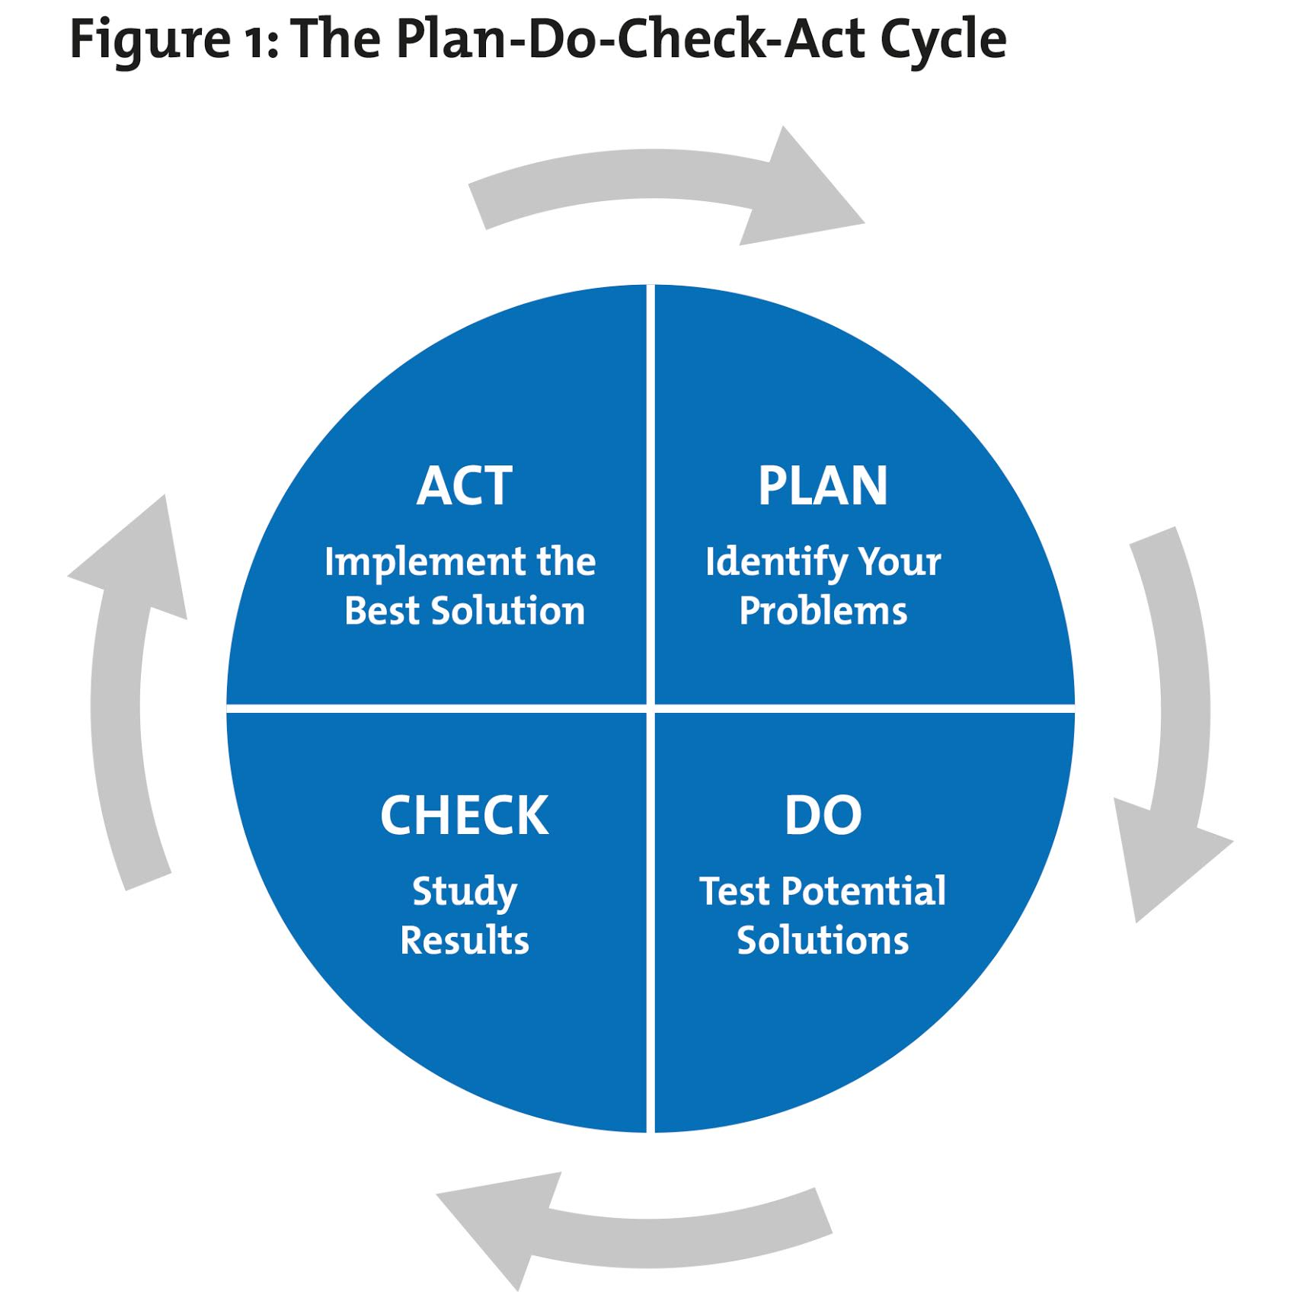

1. Plan

First, you need to identify and understand your problem, or the opportunity that you want to take advantage of. Using the first six steps of [The Simplex Process](https://www.mindtools.com/pages/article/newCT_10.htm)   can help you to do this, by guiding you through a process of exploring information, defining your problem, generating and screening ideas, and developing an implementation plan.

At the final part of this stage, state quantitatively what your expectations are, if the idea is successful and your problem is resolved. You'll return to this in the Check stage.

2. Do

Once you've identified a potential solution, test it with a small-scale pilot project. This will allow you to assess whether your proposed changes achieve the desired outcome, with minimal disruption to the rest of your operation if they don't. For example, you could organize a trial within a department, in a limited geographical area, or with a particular demographic.

As you run the pilot project, gather data to show whether the change has worked or not. You'll use this in the next stage.

3. Check

At this stage, you analyze your pilot project's results against the expectations that you defined in Step 1 to assess whether the idea has worked or not. If it hasn't worked, you return to Step 1. If it has worked, you go on to Step 4.

You may decide to try out more changes, and repeat the Do and Check phases – don't settle for a less-than-satisfactory solution. Move on to the final phase (Act) only when you're genuinely happy with the trial's outcome.

4. Act

This is where you implement your solution. But remember that PDCA / PDSA is a loop, not a process with a beginning and an end. This means that your improved process or product becomes the new baseline, and you continue to look for ways to make it even better for your organization or customers.

|  |  |  |  |  |
| --- | --- | --- | --- | --- |
| Phase | Step | Action according to PDCA | Action not according to PDCA | Reasons/Why |
| Plan | Analyze current condition | Gather people with relevant knowledge and experience | Fast to next step Missing fact based solution | Time pressure Quick fixers |
| Root cause analyses |  | Fast to conclude without analysing the root causes | Time pressure Quick fixers |
| Define performance measurement | Use mainly customer specifications | Insufficient measurement when not a customer requirement | Customer- oriented |
| Establish improvement plan | To do list | Not always a formal plan | Satisfy customer Not found of documentation |
|  |
| Do | Implement improvement plan | Implement action according to the plan |  | Doers |
| Check | Evaluation of results | Using to do list Formal meeting Informal meeting Start on Plan phase again when necessary | Stop further investigation when satisfied customer | Time pressure Tight contact with customer |
| Act | Learning/ standardizing | Informal communication Some documentation especially when customer is involved | Insufficient documentation Not systematically standardize  Not systematically according to findings | Time pressure Don’t see the value of documentation |
| Next improvement issue |  | Not systematically according to findings | Customer oriented which influence on next improvement issues |
|  |  |